9/17/2019

By: Together We Can

InfoTech Professionals Pty LtdTO: ahmad saeed

User and Installation Manual

**ABOUT THIS DOCUMENT**

**DETAILS**

|  |  |
| --- | --- |
| **FILE NAME:** | **INSTALLATION AND USER DOCUMENTATION** |
| **PRODUCED USING:** | **Microsoft Word 2016** |

**Purpose**

The purpose of this documentation is to provide a manual that a user of the ‘**Together we can’** has access to as well as specialist functions particular role have. It has also have user manual which instruct how to use the website in terms of admins and users.

Table of Contents

**Using “Together We Can” website**

**LOGIN**

To login user needs to provide email and password.

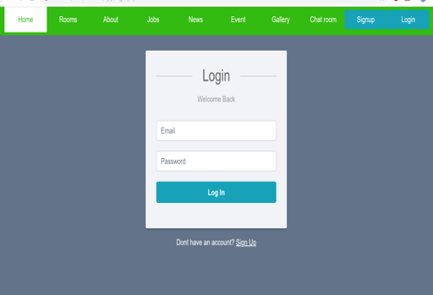

**Register**

To register user needs click sing up page which is at the top corner in right side. User needs to provide First Name, Last Name, Email, Phone Number and Password to register. 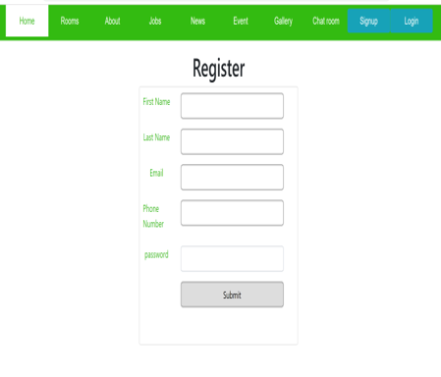

**About Us**

For more information about our website, user needs to click in About.

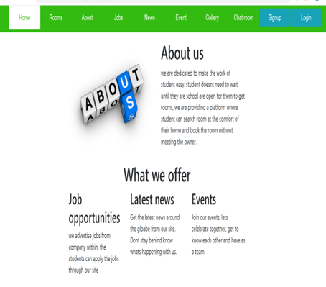

**Chat Box**

User can communicate with other user by using the chat box. Where one user can send messages to another. To send message user first need to provide Name and Enter message and then send as shown in below figure.

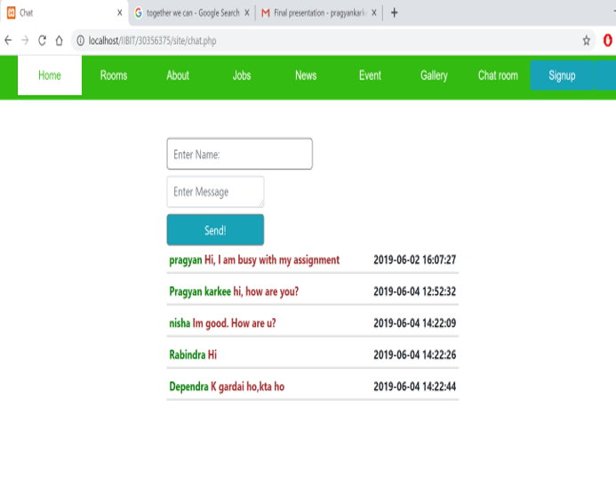

**Gallery**

User can upload their photo in the gallery. To upload the photo user need to login in website. 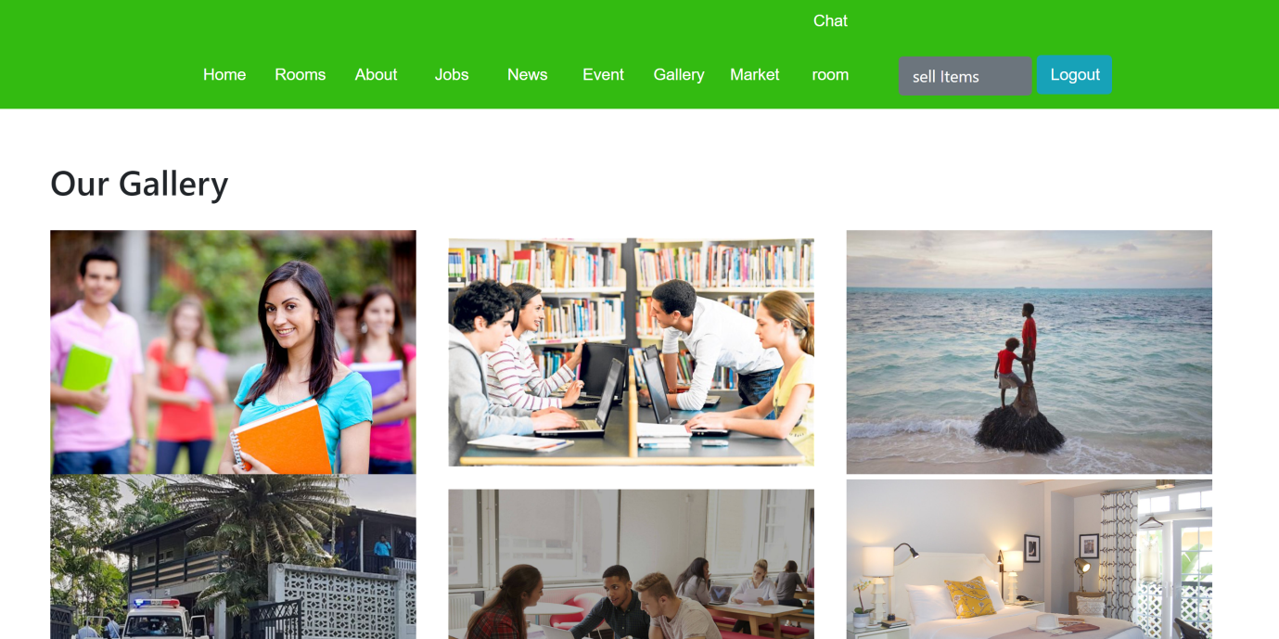

**Create Post**

Here Admin post the latest news and events happening around the Sydney, and also user can book an event.

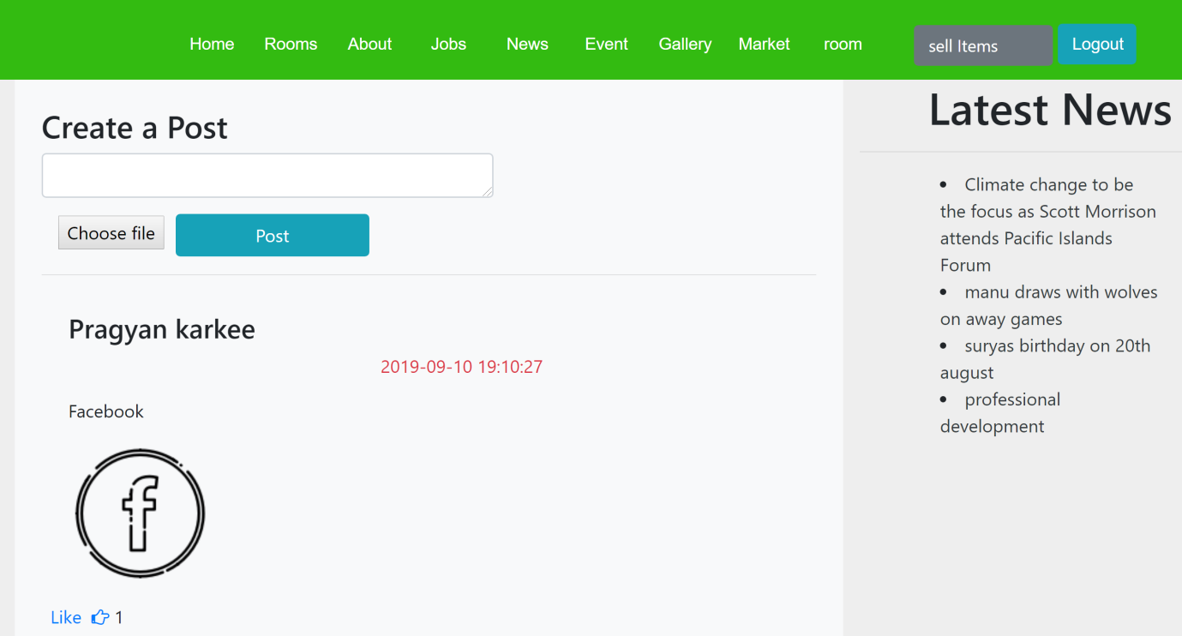

**Renting**

User can find the rooms and select the price and look for the area available near the train station. User can book for the inspection also.

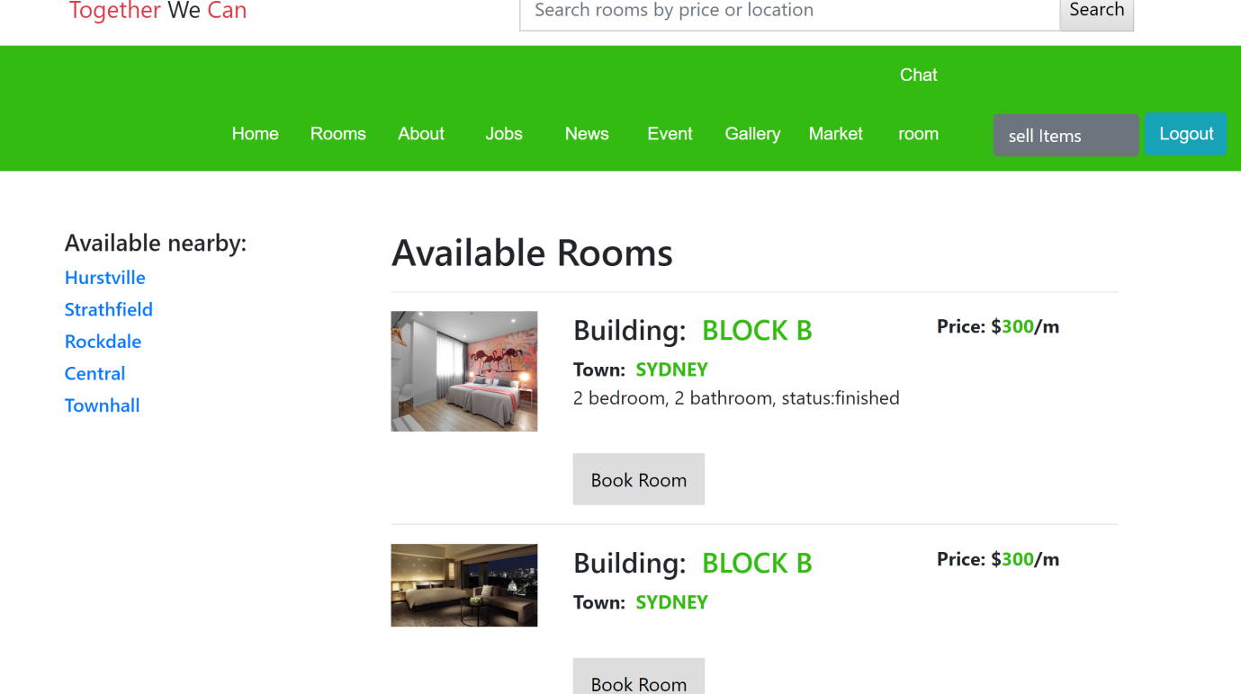

**Banking**

Information is provided how to make a bank account, what documents are needs and bank link is also provided to create a bank account.

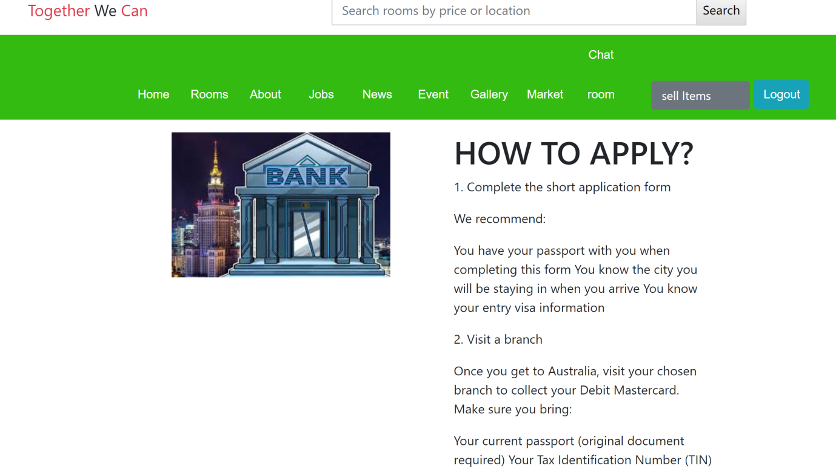

**TFN**

A first thing to do is to create Tax File Number after arriving in Australia. User founds all information in website and link is also provided from where user can create TFN.

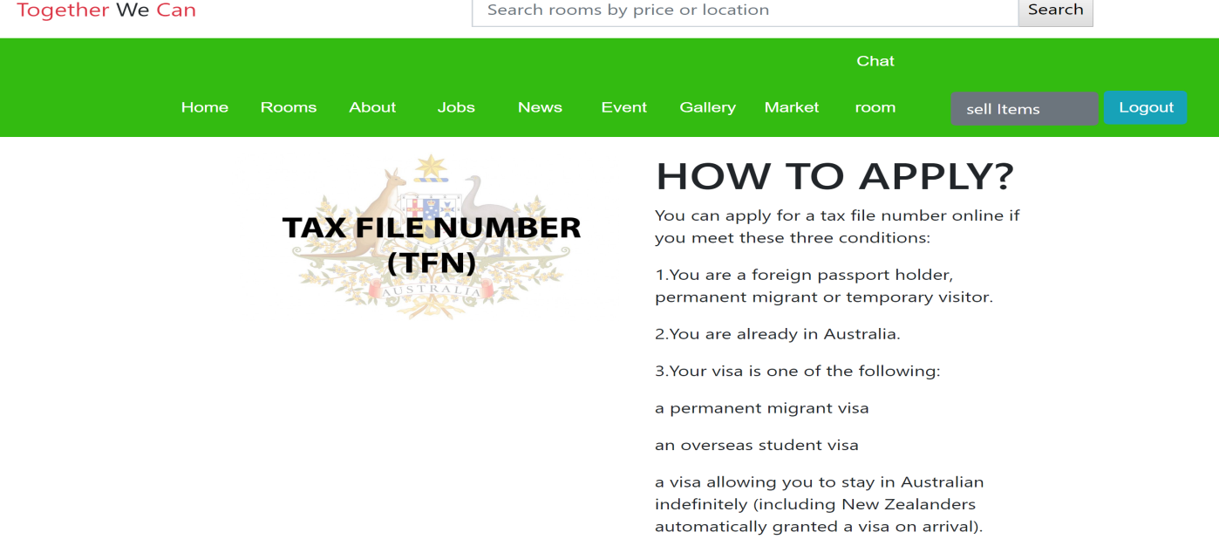

**Driving**

All information is given about how to get License in Australia. Link is given from where users can a book date for DKT exam and can do the further process.

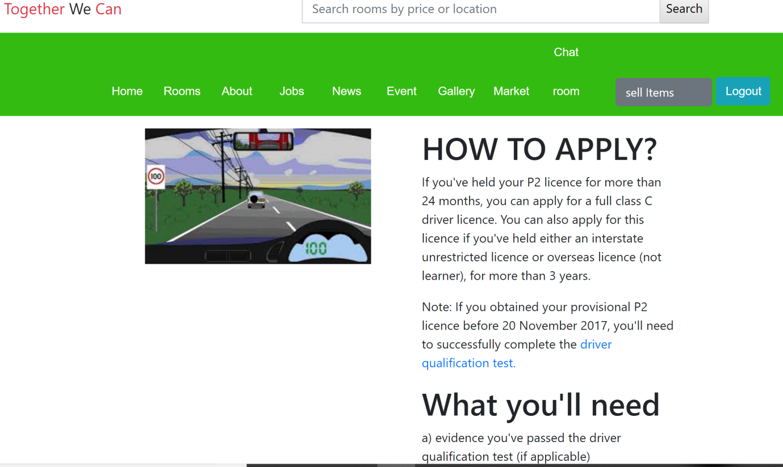

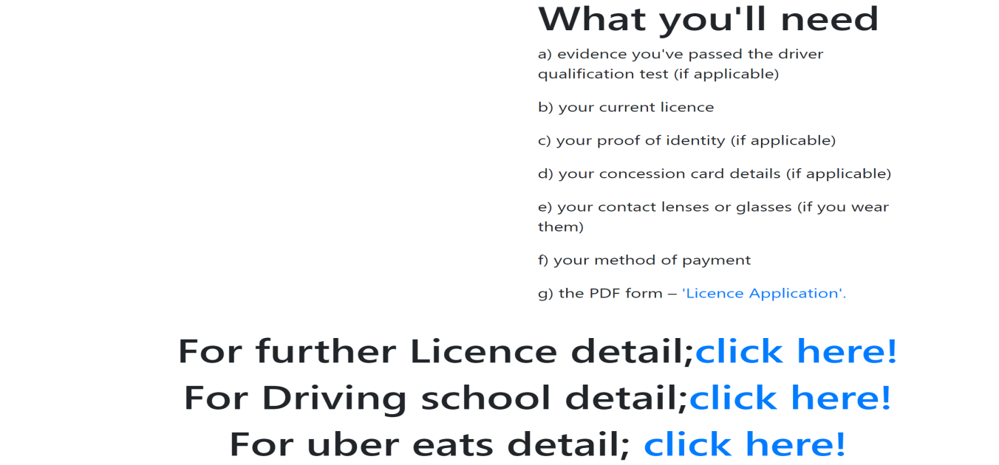

**Photo ID**

Information is given of the process of making Photo ID in Australia, like what documents are needs to apply and so on. And link also provided to user so they can get better idea of it.

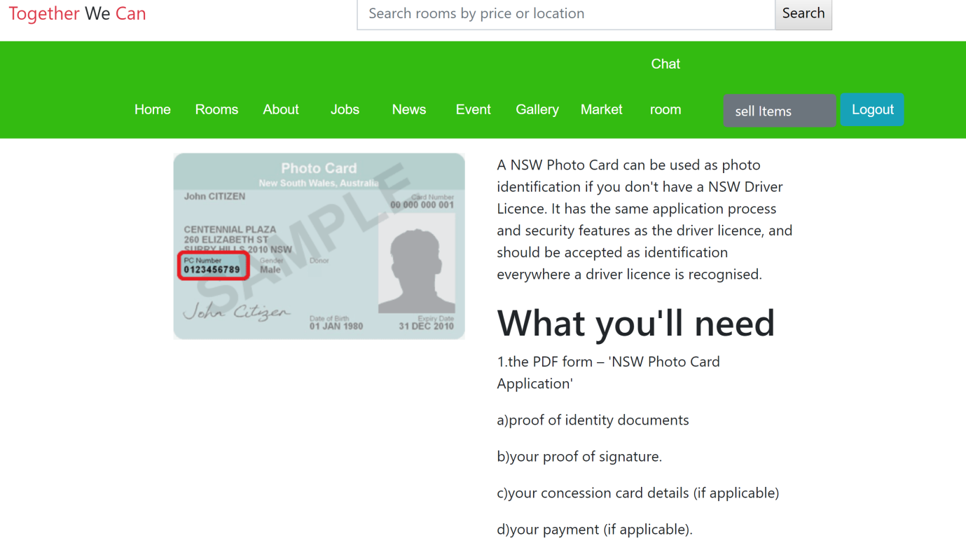

**Room**

Here admin update post in the admin page. Admin can add and delete their post.

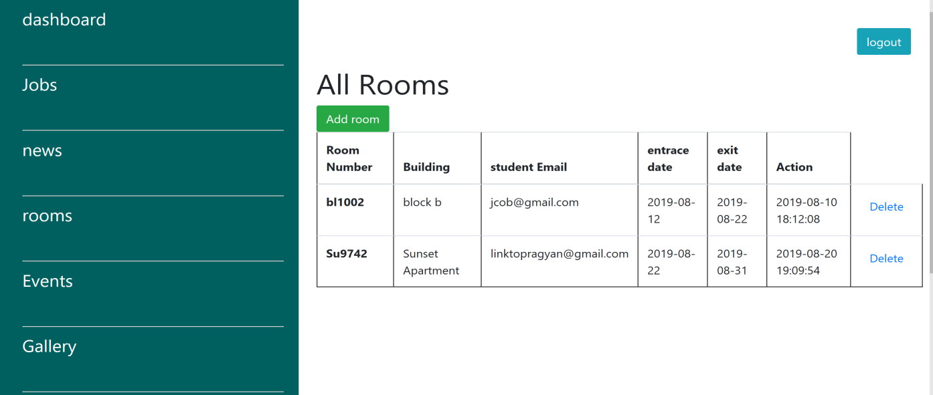

**Sell Items**

User can sell their items in our website, and also buy.

